

**Shrek-Juice**

**Documentation**

|  |  |
| --- | --- |
| **Authors:** | **C1808G2-Group 1** |
| **Khanh Le Van**  **Anh Dinh Viet**  **Long Pham Thanh**  **Tuan Dao Van** |
| **Date:** | **18-Mar-2019** |
| **Instructor:** | **Diep Tran Van** |

**Hanoi, 18-Mar-2019**

INDEX

1. Problem Definition 3

1.1. Problem Abstraction 3

1.3.1. Boundaries of the System 4

1.3.2 Hardware and Software Requirements 4

2. Customer Requirements Specification 5

2.1 Users of the System 5

2.2 System functions 5

3. System Designs 8

3.1 Entity Relationship Diagram 8

3.2 Database Design 8

3.3 Sitemap 11

3.4 System functions design 11

4. Instructions for installing the system 17

5. User Guide 23

5.1. Navigation Bar 23

5.1. Footer 24

5.2. Trang chủ 24

5.3. Giới thiệu 25

5.4. Nhượng quyền 27

5.5. Phục vụ 27

5.6. Phản hồi và liên hệ(feedback and contact us) 27

5.7. Login 28

5.9. Admin page (username:admin, password:123456) 29

6. Task sheet 33

5. Validation Checklists 35

# Problem Definition

## Problem Abstraction

Shrek Juice center is a large, famous juice center specializing in providing many quality products to the market and serving activities such as weddings, performances .... Recently, the center management wanted to expand the product line of the center and the need to renew the company's old website interface to better serve the needs of its customers. Shrek-juice.com website again.

We hope to bring a new and more friendly interface to customers and help you be more satisfied with the support we bring to customers such as ordering online, searching for products ...

* 1. **The Current System**

Our current website provides information about our product catalog and products to our customers. But when customers have a need to search for products or when they have a need to place an order right at the website, or the feedback about the product or service of the center becomes inconvenient due to the fact that the site does not yet have any This support.

* 1. **The Proposed System**

The new website allows customers to perform product search operations, send feedback and trademark franchise registrations if required, allowing customers to order online on itself.

On the management side, the website allows them to have the ability to perform manipulations to edit, delete catalog and product information or add new categories and products to the website.

### Boundaries of the System

The website serves all customers using internet-connected devices such as laptops, computers, tablets or smartphones meeting the requirements in section 1.3.2

### 1.3.2 Hardware and Software Requirements

Hardware requirements

* Intel Pentium 4 or higher
* 512MB RAM or better

Software requirements

* HTML5 and javascript support browsers such as Chrome, IE,…

# Customer Requirements Specification

* 1. **Users of the System**

Users of the system are admin and customers

* Customer:

See product catalog, product list and product details.

See referral information of the center.

View the center's operating time and service policy.

See contact method and send feedback on products, service quality and other comments to the center.

Register for franchise business with us if required.

Place an order on the website.

* Admin:

Create, edit, delete product and product categories.

View the list of registered franchises.

View the list of customer feedback.

View the list of orders and line items customers have ordered.

## 2.2 System functions

*Customer system function:*

* Search product
* Input: search string
* Output: the list of products is approximate to the customer string entered.
* How to handle: when the user enters the search string into the system, the system will retrieve the imported customer data in comparison with the product name in the database and return the products with the same name as the search string. Search for entered customers.
* Feedback
* Input: customer information, title and feedback.
* How to handle: when users enter full information and feedback and send to the system. The system will retrieve the stored customer data into the corresponding database for administrators to read.
* Information to store: customer information and feedback.
* Register for a franchise
* Input: registration information.
* How to handle: when users enter full registration information and send to the system. The system will retrieve the stored customer data into the corresponding database for administrators to read.
* Information to store: registration information.
* Order online
* Input: customer contact information, product list selected by the customer.
* How to handle: after the user has entered all contact information, the system will retrieve customer data and the list of products the user has selected into the corresponding database.
* Information to store: customer contact information and selected products.

*Administration system functions:*

* Edit
* Input: catalog information, revised products.
* How to handle: when admin chooses products or categories that need fixing information. The system will retrieve the old information from the database for admin to view and edit the information. After the admin modifies the information, the system will update the revised information.
* Information to store: input data
* Delete
* Input: product id, selected item id.
* How to handle: after admin selects the product, the list needs to delete the system will record and delete the information of the product, the list to be deleted
* Create
* Input: product information, new product catalog.
* How to handle: after admin enter catalog information, new product system will record information and store into corresponding data base.
* Store information: admin input data.

# System Designs

## 3.1 Entity Relationship Diagram

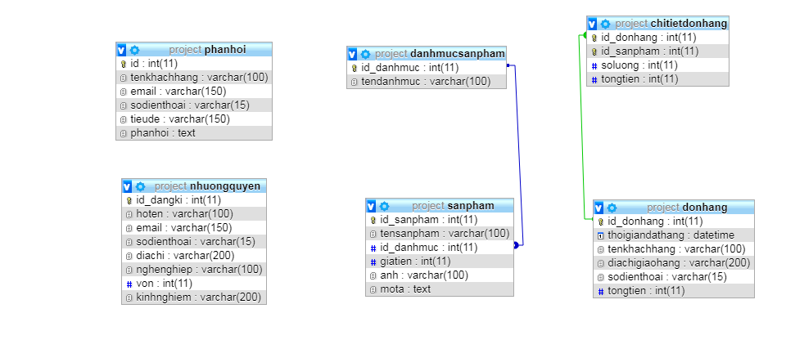

## 3.2 Database Design

|  |  |  |
| --- | --- | --- |
| TABLE ‘danhmucsanpham’ | | |
| Column name | Type | Attribute |
| id_danhmuc | Int(11) | Primary key  Auto_increment |
| tendanhmuc | Varchar(100) |  |

|  |  |  |
| --- | --- | --- |
| TABLE ‘sanpham’ | | |
| Column name | Type | Attribute |
| id_sanpham | Int(11) | Primary key, auto_increment |
| tensanpham | Varchar(100) |  |
| id_danhmuc | Int(11) |  |
| giatien | Int(11) |  |
| anh | Varchar(100) |  |
| mota | text |  |

|  |  |  |
| --- | --- | --- |
| TABLE ‘phanhoi’ | | |
| Column name | Type | Attribute |
| id | Int(11) | Primary key, auto_increment |
| tenkhachhang | Varchar(100) |  |
| email | Varchar(150) |  |
| sodienthoai | Varchar(15) |  |
| tieude | Varchar(150) |  |
| phanhoi | text |  |

|  |  |  |
| --- | --- | --- |
| TABLE ‘nhuongquyen’ | | |
| Column name | Type | Attribute |
| id_dangki | Int(11) | Primary key, auto_increment |
| hoten | Varchar(100) |  |
| email | Varchar(150) |  |
| sodienthoai | Varchar(15) |  |
| diachi | Varchar(200) |  |
| nghenghiep | Varchar(100) |  |
| von | Int(11) |  |
| kinhnghiem | Varchar(200) |  |

|  |  |  |
| --- | --- | --- |
| TABLE ‘donhang’ | | |
| Column name | Type | Attribute |
| id_donhang | Int(11) | Primary key, auto_increment |
| thoigiandathang | datetime |  |
| tenkhachhang | Varchar(100) |  |
| diachigiaohang | Varchar(200) |  |
| sodienthoai | Varchar(15) |  |
| tongtien | Int(11) |  |

|  |  |  |
| --- | --- | --- |
| TABLE ‘chitietdonhang’ | | |
| Column name | Type | Attribute |
| id_donhang | Int(11) | Primary key |
| Id_sanpham | Int(11) | Primary key |
| soluong | Int(11) |  |
| tongtien | Int(11) |  |

## 3.3 Sitemap

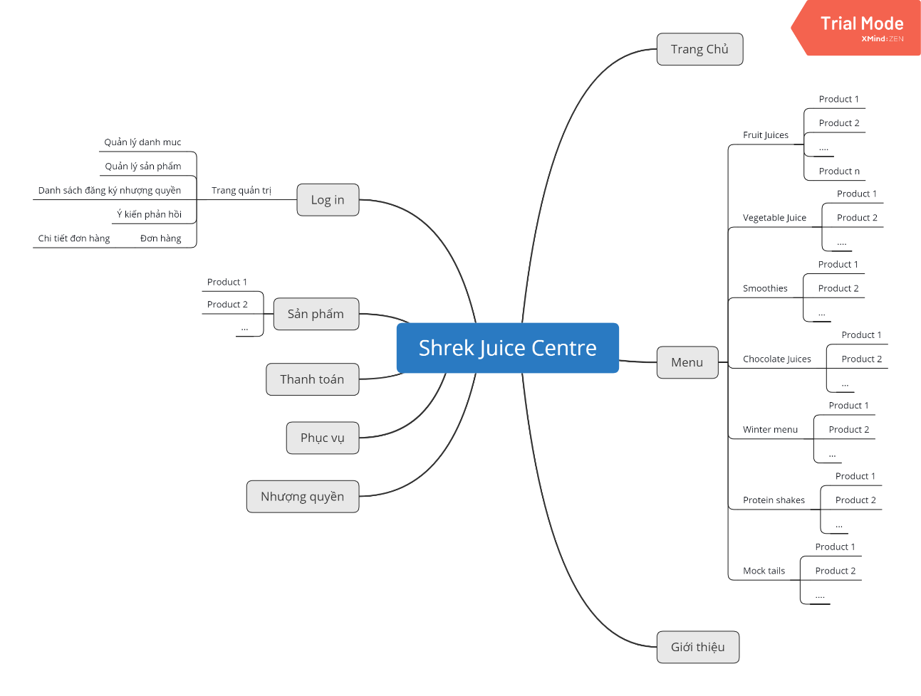

## 3.4 System functions design

Customer system function

* Search product
* Input: search string.
* Process: Search for products whose name is similar or similar to the search string in the database.
* Output: product list if exist or message if not exist

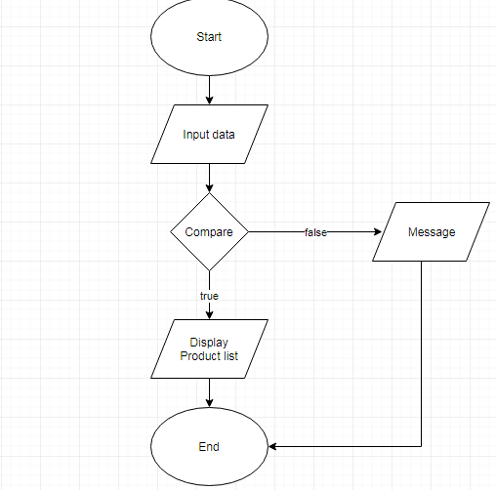

* Feedback, Register for a franchise, Order online
* Input: customer information.
* Process: check validate data, insert data into database.

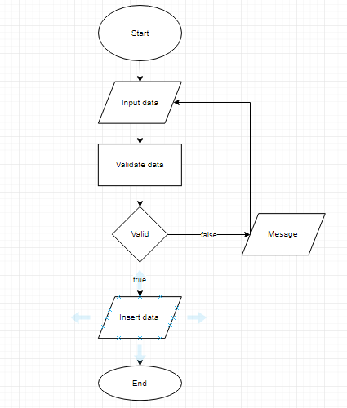

Administration system functions

* Edit
* Input: revised data of catalog and product.
* Process: validate data, update data into database.

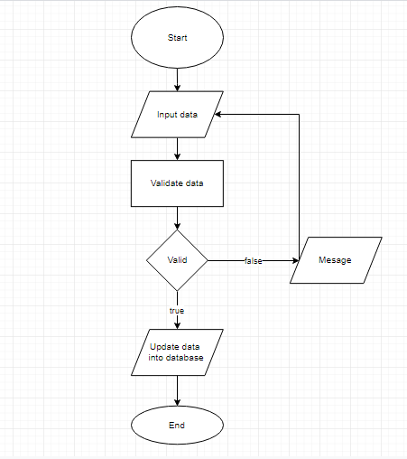

* Delete
* Process: delete catalog,product choose.

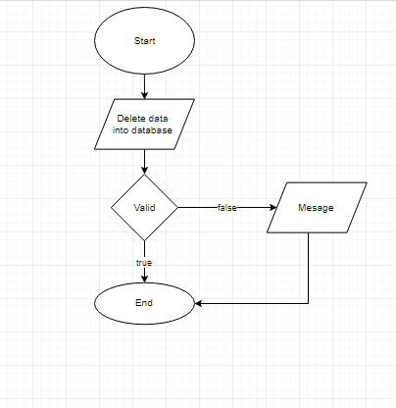

* Create
* Input: data of catalog or product
* Process: validate data, insert data into database



1. **Instructions for installing the system**
2. Download and install xampp latest version.

Link download: <https://www.apachefriends.org/download.html>

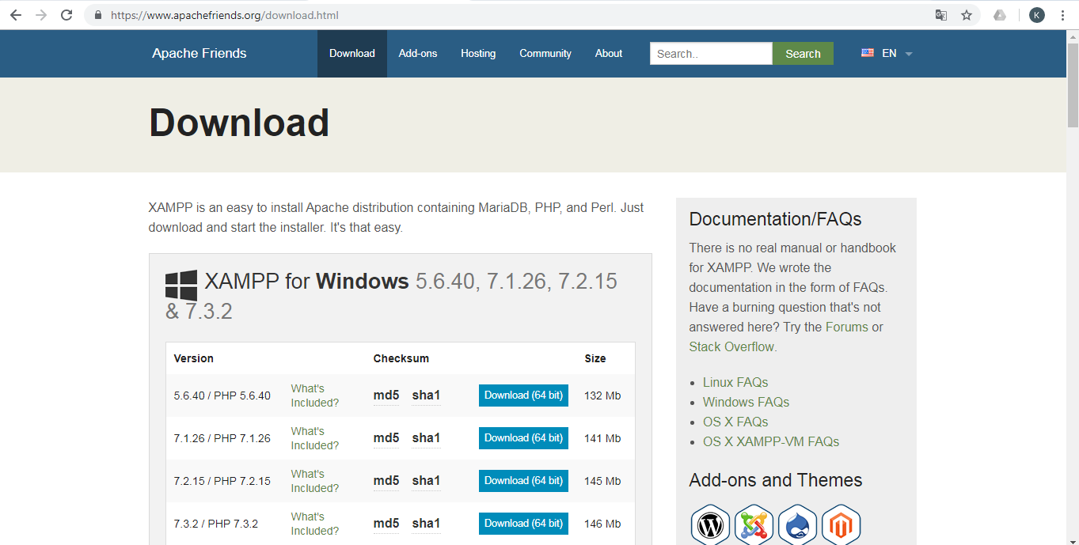

Link view detailed installation instructions: <https://www.wpblogx.com/install-xampp-on-windows/>

1. Copy the Eproject folder in the Source folder into the htdoc directory in the xampp folder. Link htdoc folder: C:\xampp\htdocs

* Copy Eproject folder

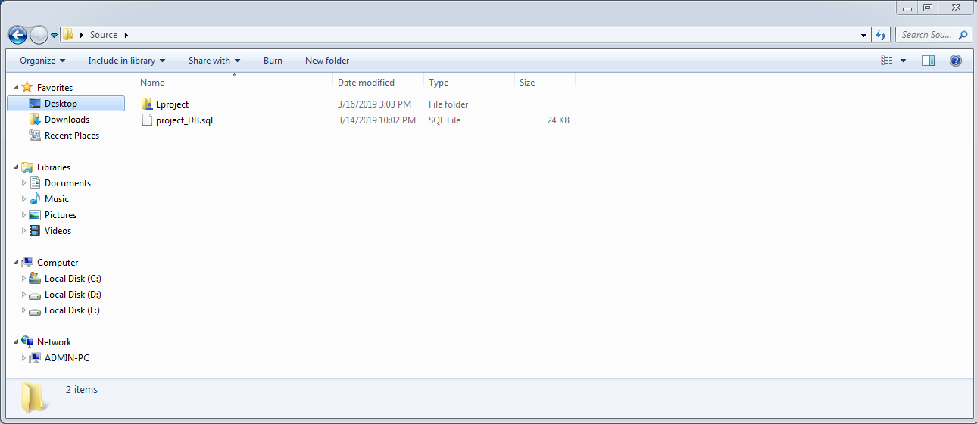

* Goto the path: C:\xampp\htdocs

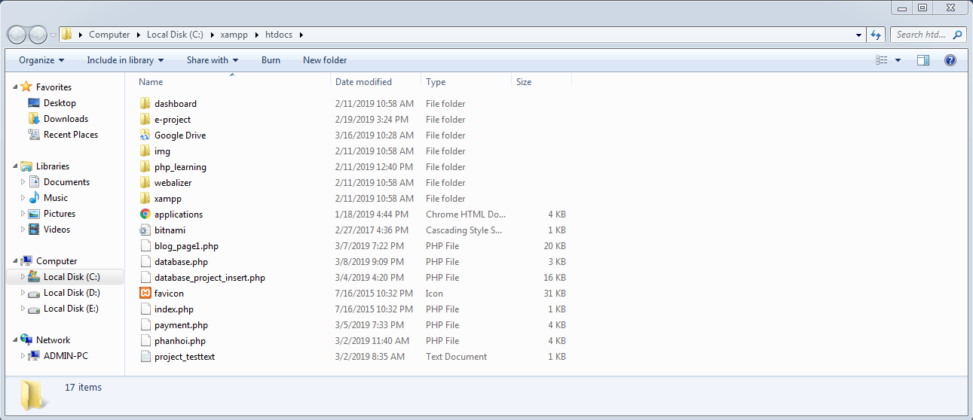

* Paste folder Eproject:

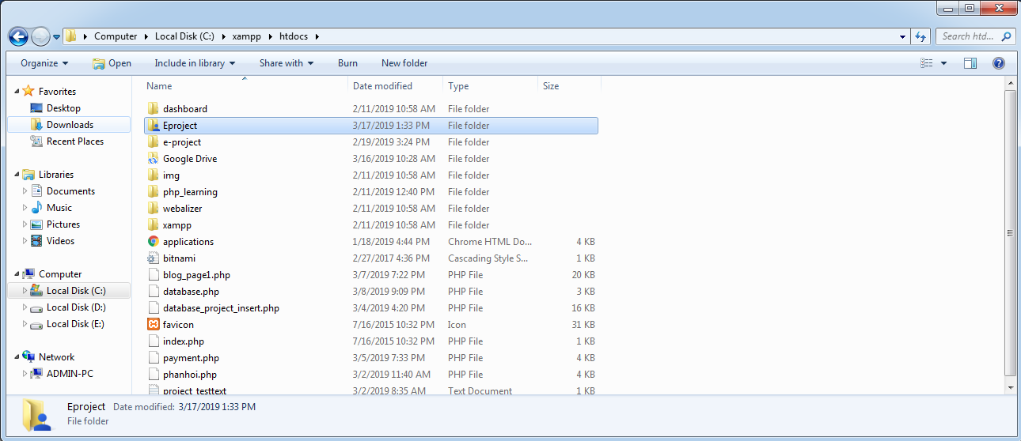

1. Open xampp control panel. start Apache,Mysql.

- Click start of windows

- Input xampp control panel and press enter

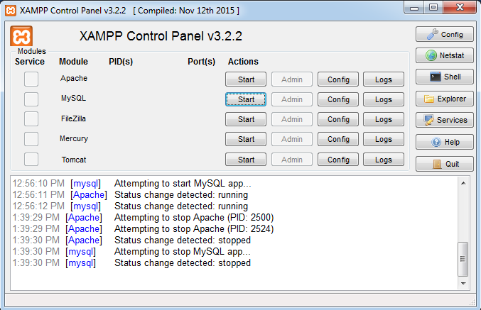

* Click start at apache and MySQL

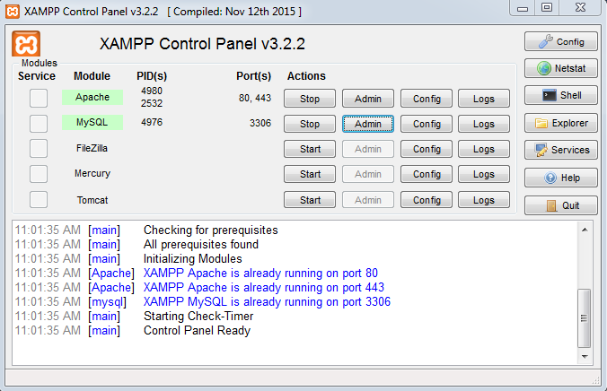

1. Open the web browser, go to the link: <http://localhost/phpmyadmin/>.
2. Create database named project. Click New.

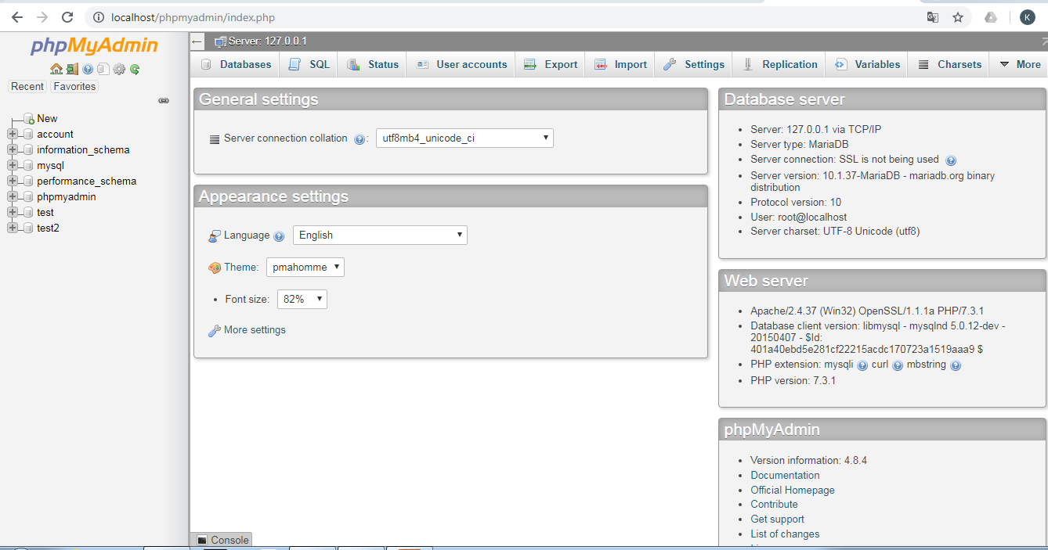

1. Select the database you just created above, import the data from file project_DB.sql in the source directory.

* Click Import

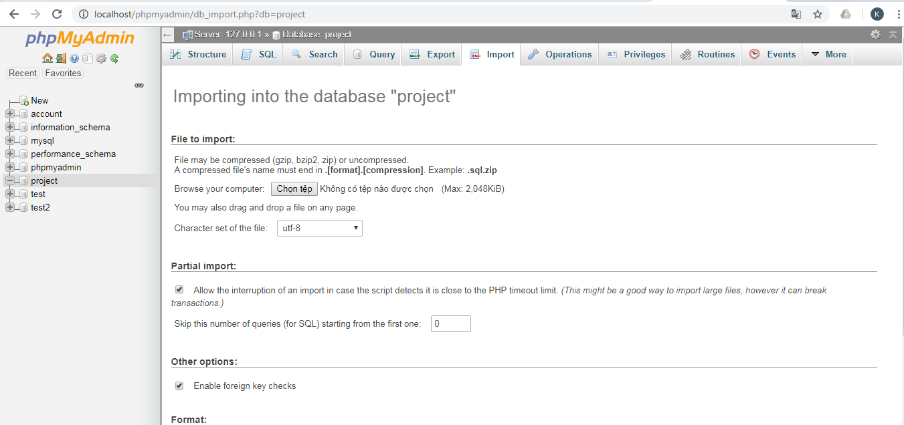

* Click chọn tệp. Go to the Source folder and select file project_DB.sql. Click Open

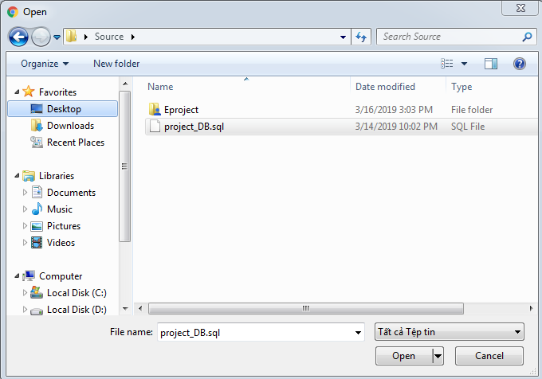

* Click Go

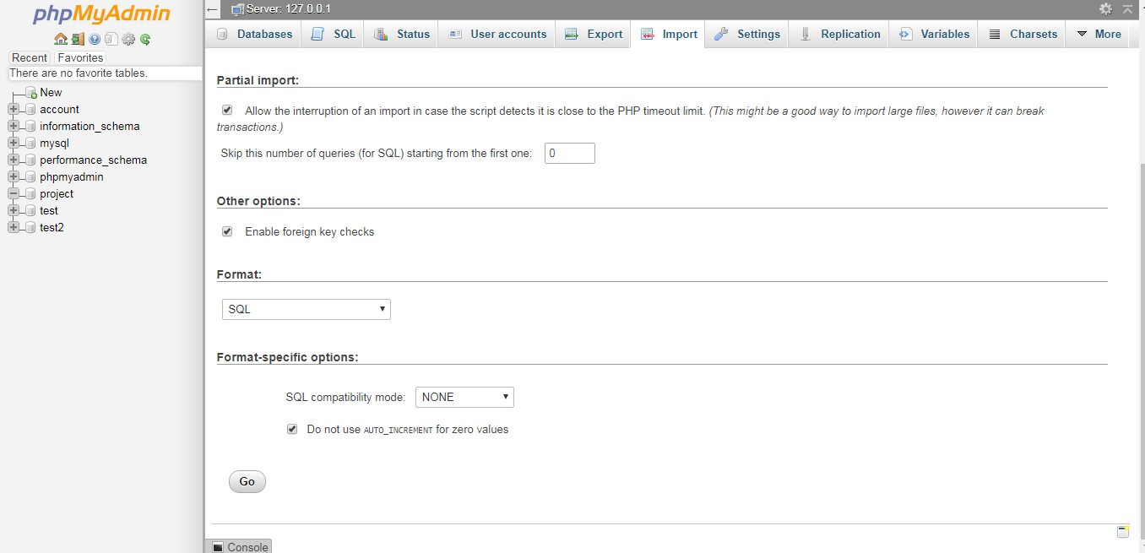

* Wait a bit for MySQL to handle. Then we get results:

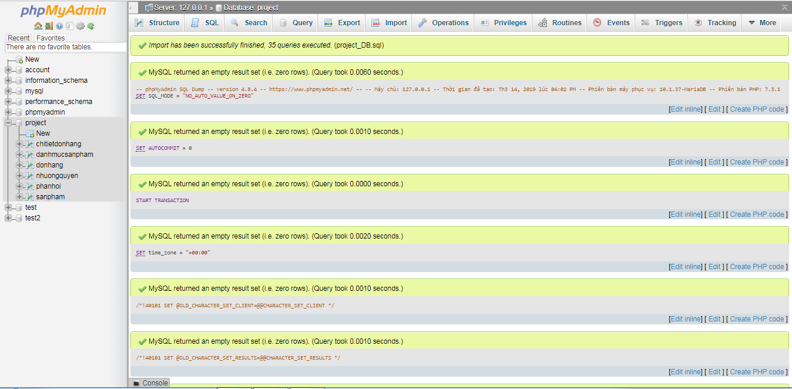

1. After completing the above steps, open the web browser on the link:

http: //localhost/Eproject/Shrek-juice.com/index.php to view the web page.

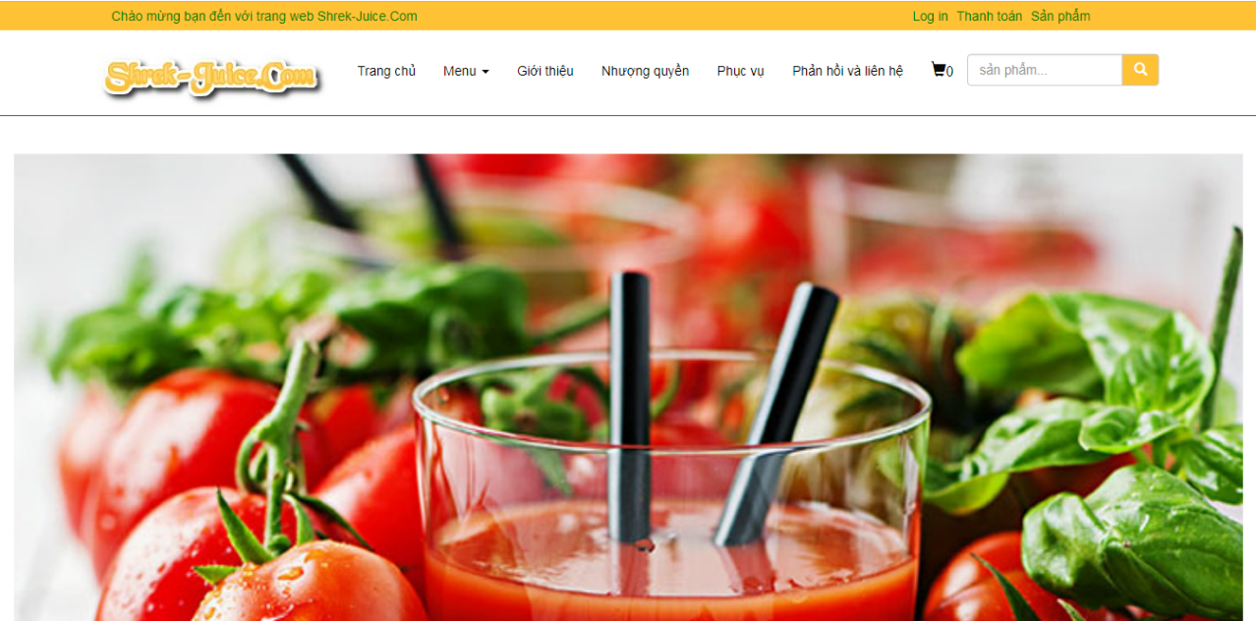

# User Guide

## 5.1. Navigation Bar



**Navigation**

This bar is located on the top of the website. If redirects you to the different areas of the website.

* **Trang chủ(home page):** home page includes new products, suggested products
* **Login:** Diplay login page
* **Thanh toán(order):** display order details, forms for customers to provide contact information and order confirmation
* **Sản phẩm(product):** Display all products and categories for customers
* **Menu:** show product catalog
* **Giới thiệu(about us):** Information about us
* **Nhượng quyền(**Franchise**):** Franchise registration
* **Phục vụ(catering):** service policy, service time
* **Phản hồi và liên hệ(feedback and contact us):** Contact us information and customer feedback form
* **Search box:** Search product
  1. **Footer**



**Footer**

Display collapses information about us, contact information and service policies.

* 1. **Trang chủ**

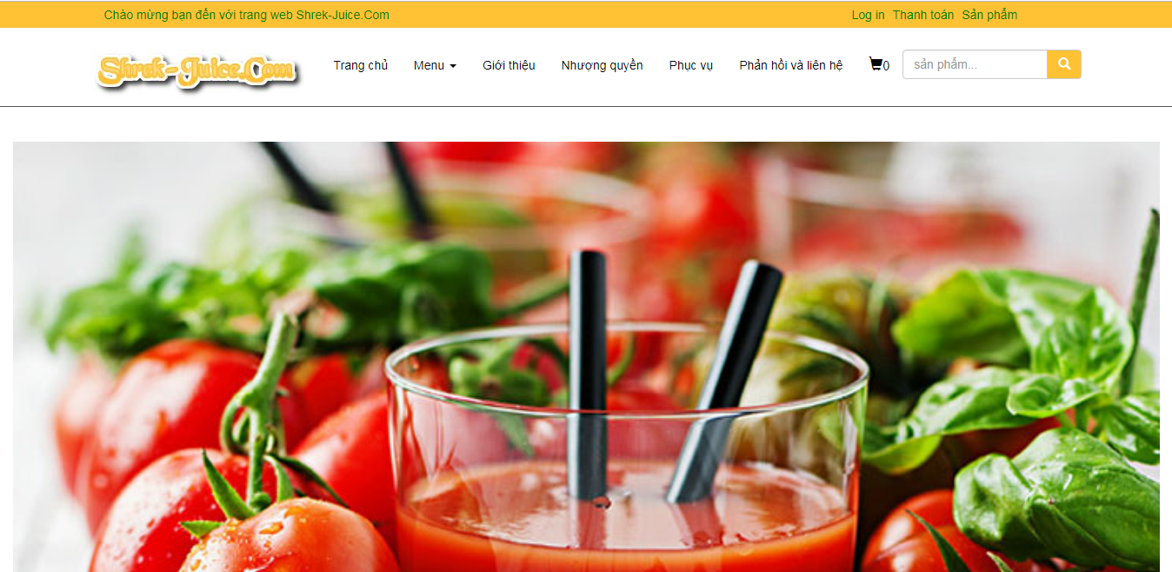

On the top is the image.

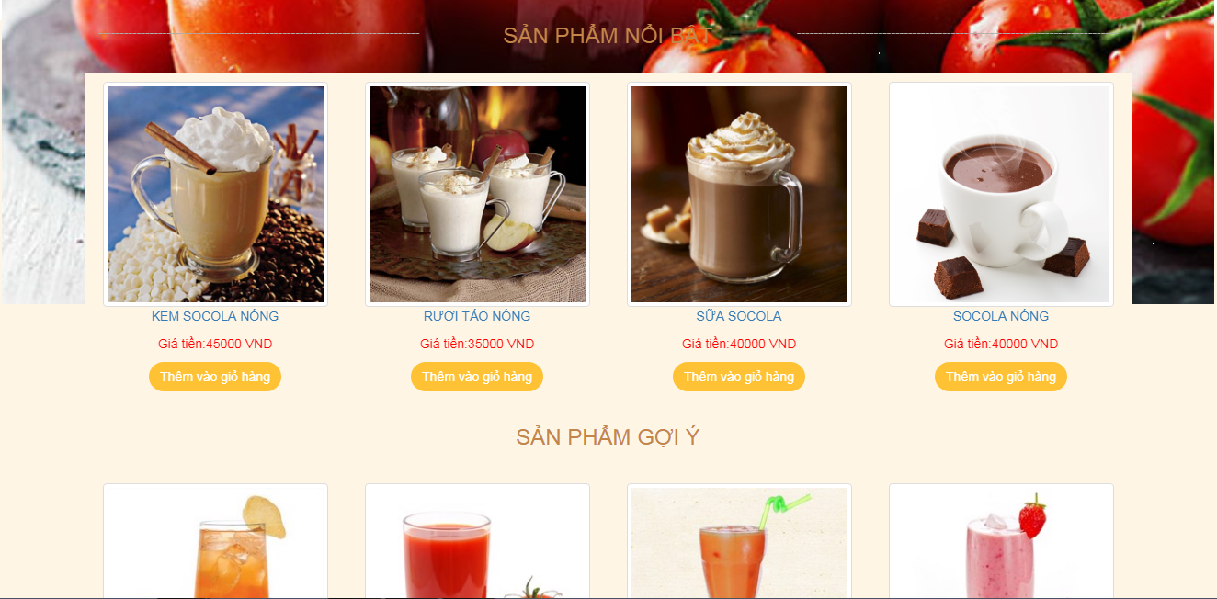

Below is a list of some of our new products, outstanding products.

* 1. **Giới thiệu**



On the top is the image.



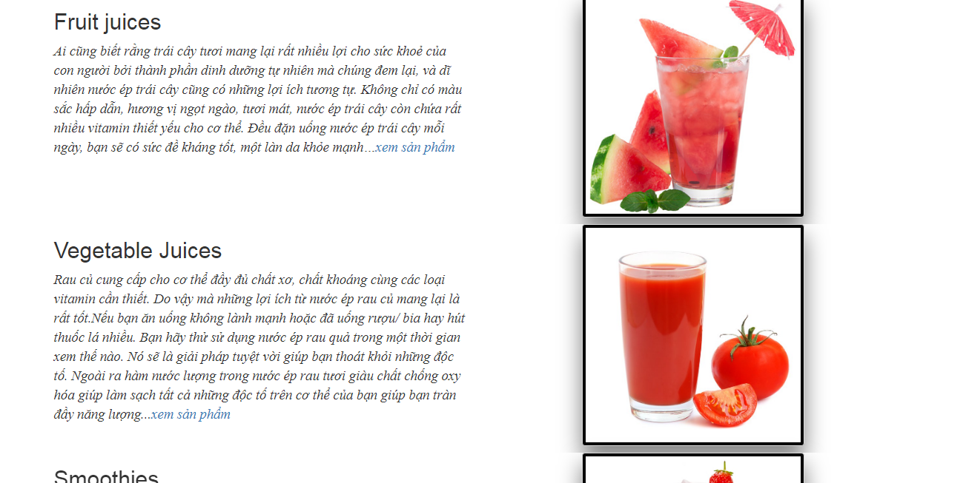

The bottom is about us and our products.

* 1. **Nhượng quyền**

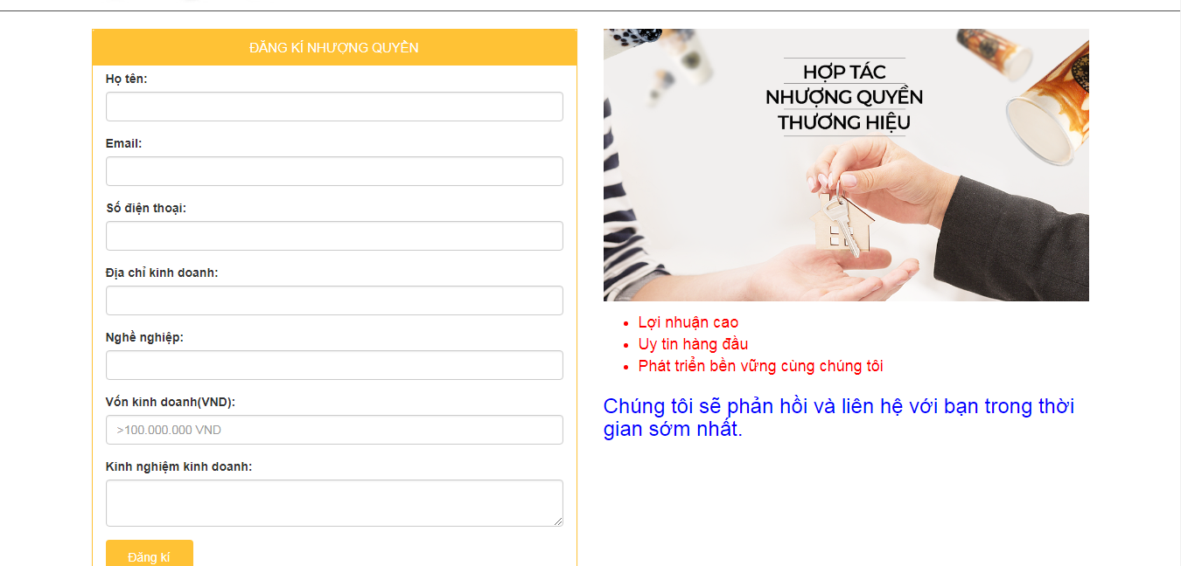

* 1. **Phục vụ**

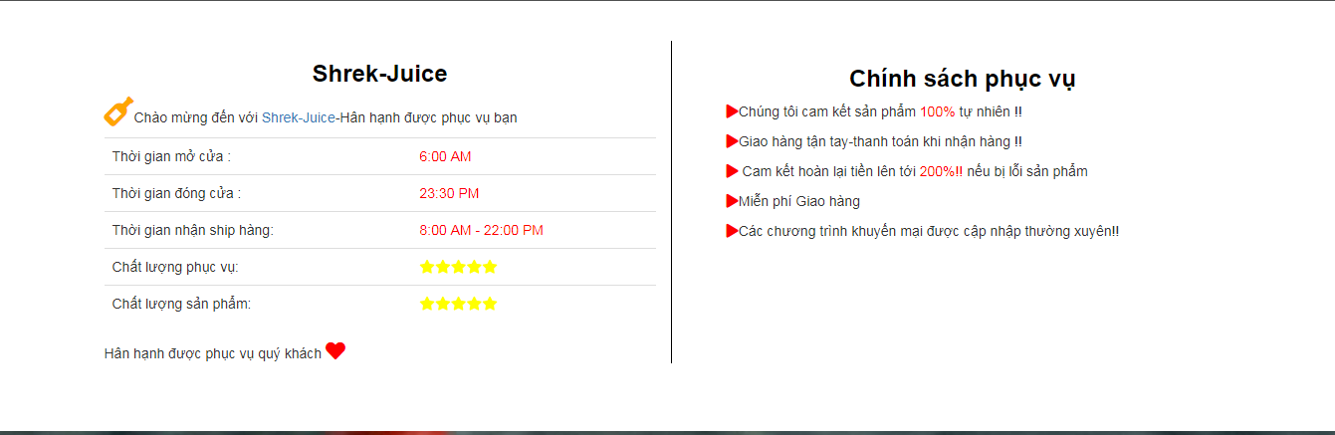

* 1. **Phản hồi và liên hệ(feedback and contact us)**

Map location

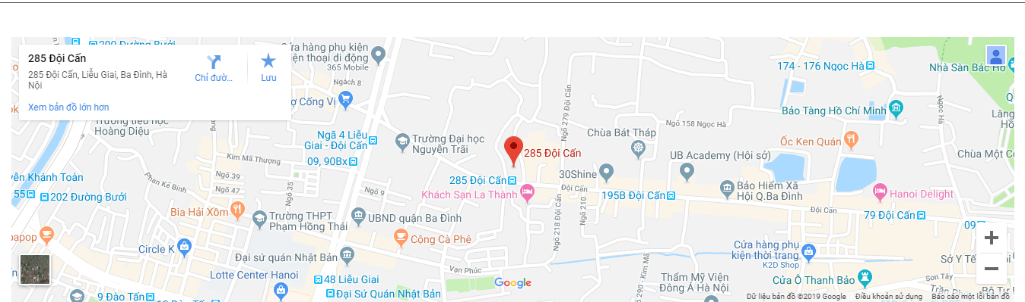

Feedback and contact

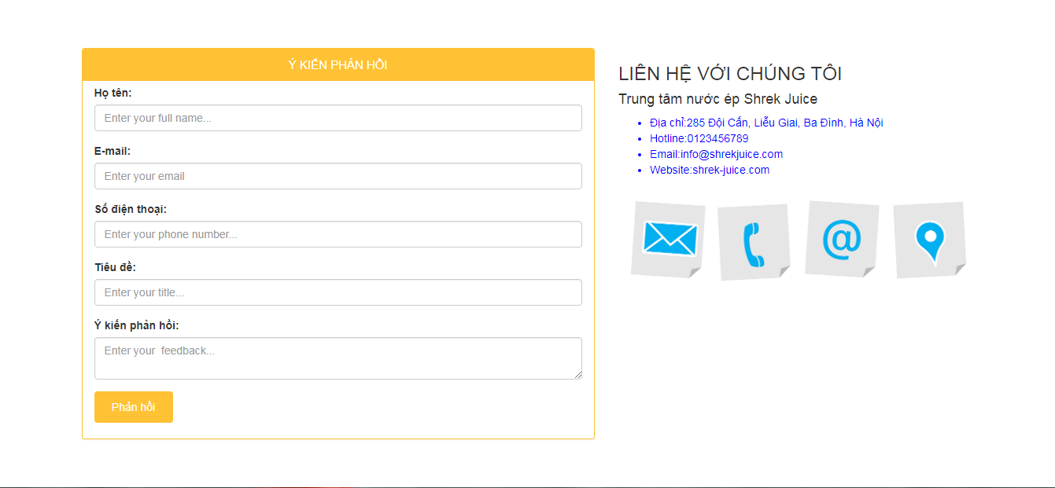

* 1. **Login**

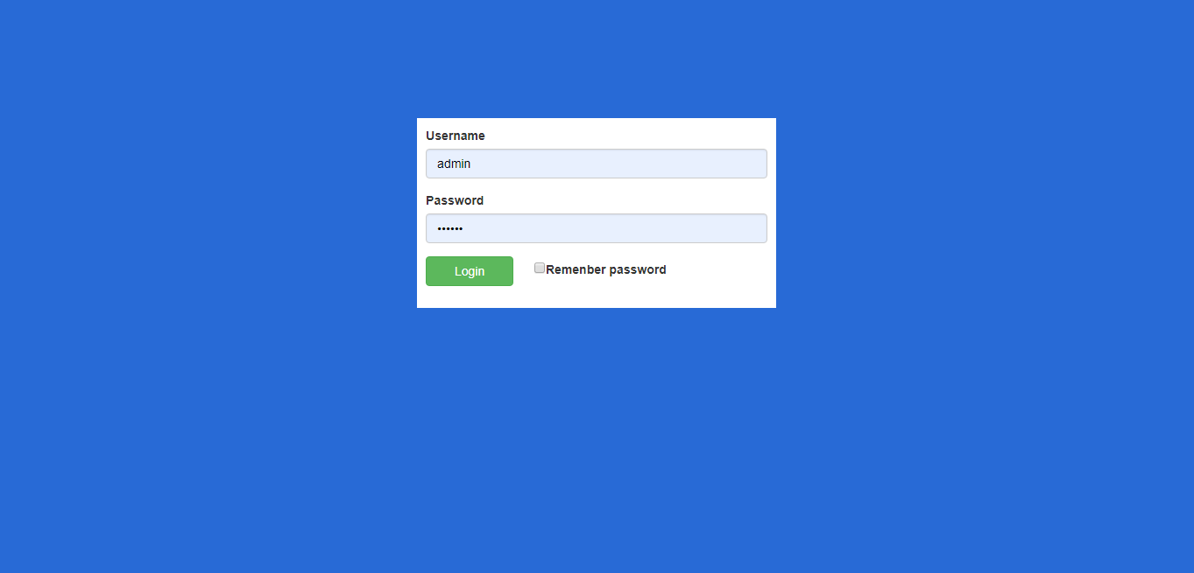

When the user clicks login, displays the login form. if admin entered correctly:

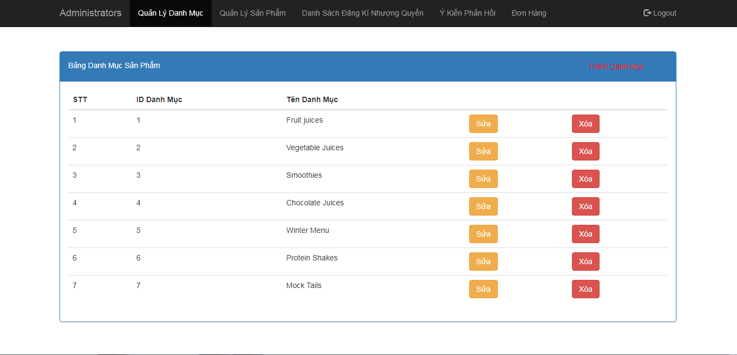

Otherwise the login message fails.

## 5.9. Admin page (username:admin, password:123456)

Admin page include:

-Quản Lý Danh Mục: Display product catalog, allow admin to edit, delete product catalog and create new categories.



-Quản Lý Sản Phẩm: display a list of all products, allow admin to edit product information, delete products and create new products.

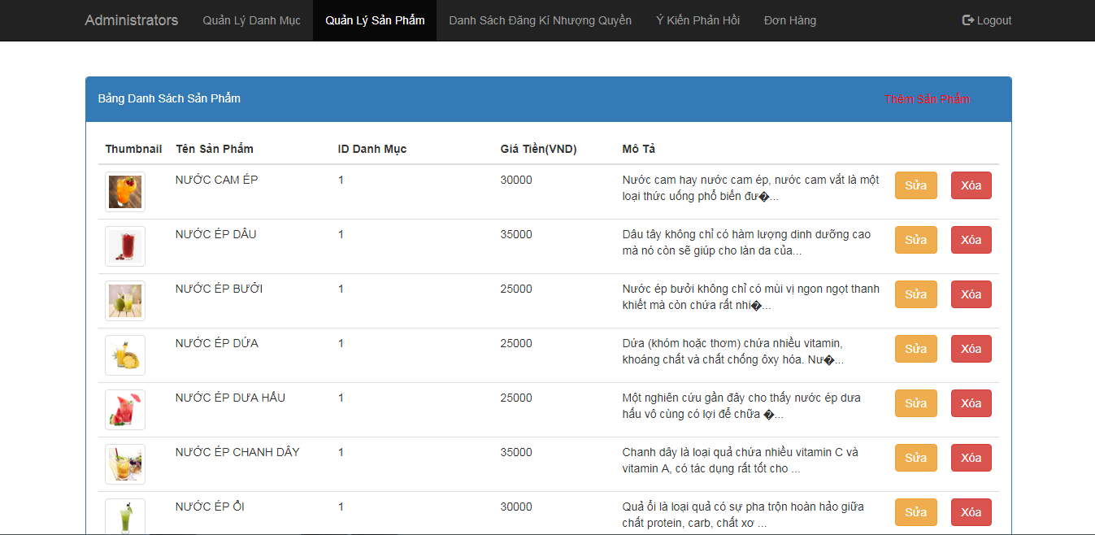

-Danh Sách Đăng Kí Nhượng Quyền: display a list of franchise registrations and related information.

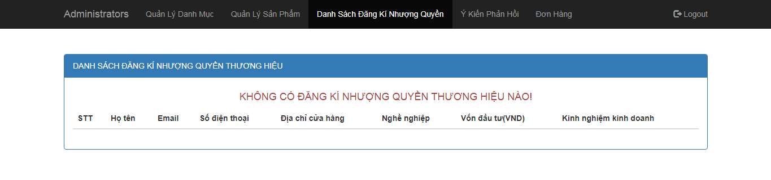

-Ý kiến Phản Hồi: display a list of customer feedback.

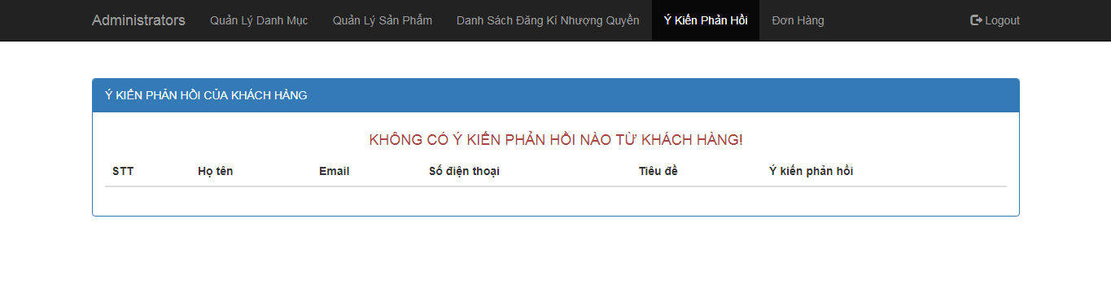

-Đơn Hàng:

+show order list

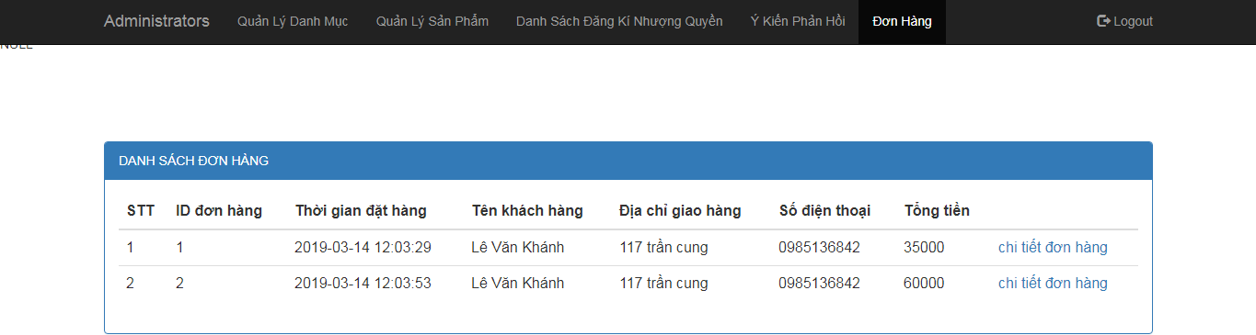

+Show order details

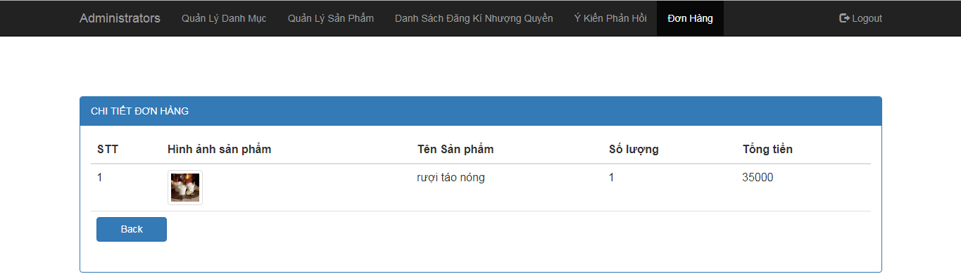

-Logout: back to home page.

# Task sheet

|  |  |  |  |  |  |
| --- | --- | --- | --- | --- | --- |
| **Task Sheet** | | | | | |
| No | Task name | Completed by | Start date | Deadline | Status |
| 01 | Database design | All team | 18-02-2019 | 24-02-2019 | completed |
| 02 | Website header | All team | 24-02-2019 | 26-02-2019 | completed |
| 03 | Website footer | All team | 27-02-2019 | 28-02-2019 | completed |
| 04 | Home page | Tuan Dao Van | 28-02-2019 | 10-03-2019 | completed |
| 05 | Admin page  (login+admin page) | Khanh Le Van | 07-03-2019 | 10-03-2019 | completed |
| 06 | Product page | Khanh Le Van | 28-02-2019 | 02-03-2019 | completed |
| 07 | Detail product page | Khanh Le Van | 03-03-2019 | 06-03-2019 | completed |
| 08 | Order page | Khanh Le Van | 07-03-2019 | 10-03-2019 | completed |
| 09 | Feedback and contact us page | Anh Dinh Viet | 28-02-2019 | 05-03-2019 | completed |
| 10 | About us | Anh Dinh Viet | 06-03-2019 | 10-03-2019 | completed |
| 11 | Catering page | Long Pham Thanh | 28-02-2019 | 03-03-2019 | completed |
| 12 | Franchise page | Long Pham Thanh | 03-03-2019 | 10-03-2019 | completed |
| 13 | E-project document | All team | 11-03-2019 | 18-03-2019 | completed |

# 5. Validation Checklists

|  |  |  |
| --- | --- | --- |
| S.NO | Aspect tested | Suggestions/Remarks |
| 1. | Have all the modules been properly integrated andthey completely functional? | Yes |
| 2. | Does each unit meet its objective and purpose?  Are all the validations happening as specified in process | Yes |
| 3. | have all design and coding standards been followed and implemented? | Yes |
| 4. | Is the GUI design design consistent all over? | Yes |
| 5. | Are the codes working as per the specification? | Yes |
| 6. | Does the application's functionality resolve the client problem, and satisfy his needs completely? | Yes |
| 7. | Additional features and utilities that give value addition to the entire project | Yes |